Wide Mouth Frog

A simple-to-make frog puppet made from a piece of paper. This puppet's mouth moves!

* 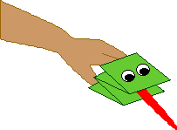A piece of green paper
* A small strip of red construction paper
* Glue
* Scissors
* Googly eyes

|  |  |
| --- | --- |
| 1 | Fold a piece of green paper in thirds, forming a long rectangle. |

|  |  |
| --- | --- |
| 2 | Fold the long rectangle into fourths, making a "W" shape. |

|  |  |
| --- | --- |
| 3 | This "W" shape will be the frog. |

|  |  |
| --- | --- |
| 4 | Draw eyes on the frog (or glue on googly eyes). |

|  |  |  |  |
| --- | --- | --- | --- |
| tongue | Cut out a long tongue from red paper and glue the end of it in the frog's mouth. | | 5 |
| done | | Put your thumb in the frog's lower jaw, and put your other fingers in the upper jaw. You now have a frog puppet that has a VERY big mouth. | |